

TEACHER VACANCY

2026 APPLICATION PACK

Kia ora,

Thank you for expressing an interest in our recently advertised teaching positions.

Our school opened in 2019 and it has been an exciting journey to establish a new school.

We are looking forward to growing our team!

This is a very special opportunity to join our whānau in a stunning new state of the art primary school.

We believe the ***culture*** of our school is one of the special reasons our staff and students thrive.

Our vision is to ***Inspire, Challenge and Empower***, and this is highly evident in our curriculum design and approach to teaching and learning.

The school roll is currently 515 students.

We are a very multicultural community with 56 countries represented, and we enjoy celebrating this diversity. Approximately 55% of our students are learning English as a second language. The school is a Public Private Partnership (PPP) school (buildings owned and maintained by a private company, but every other aspect of the school operates like a public school) designed with innovative learning environments able to accommodate up to 520 students. The school also has a specialist education unit on site which is managed by Hamilton North School.

Please find enclosed all the information you will need to apply. If you win the position you will be part of a pretty special staff culture (please see our culture survey included).

If you are an enthusiastic and innovative teacher with the talent, energy and passion to inspire, then we would love to hear from you.

Ngā mihi nui

Tony Grey

Principal

APPLICATION INFORMATION

The application process and the relevant documents are included in this pack and on our website:

1. Application form, including referee details and referee google form
2. Application checklist
3. Recruitment process/timeline

***Applications close at 9am, Friday 17th October***

WHY JOIN OUR TEAM? IN RETURN WE CAN OFFER:

* The incredible opportunity to be part of the team, and to continue to build the school from scratch.
* The opportunity to be part of a strong staff culture, where innovation and fun is fostered. Please refer to our latest Staff Culture survey
* An ***amazing*** state of the art learning environment.
* Children of Board employees are eligible for “out of zone” enrolment places, under priority 5 of the enrolment scheme. We also offer free after school care.
* A school that is deeply committed to bringing its vision and values alive.
* Strong support from our Leadership Team and Board, with full commitment to high quality personal and professional development. We invest in our people!
* The opportunity for you to utilise your talents, and to work alongside other passionate and innovative educators.
* The promise that we will inspire, challenge and empower you to become the best possible teacher.
* An incredibly supportive and positive parent community/whānau (see survey responses below)

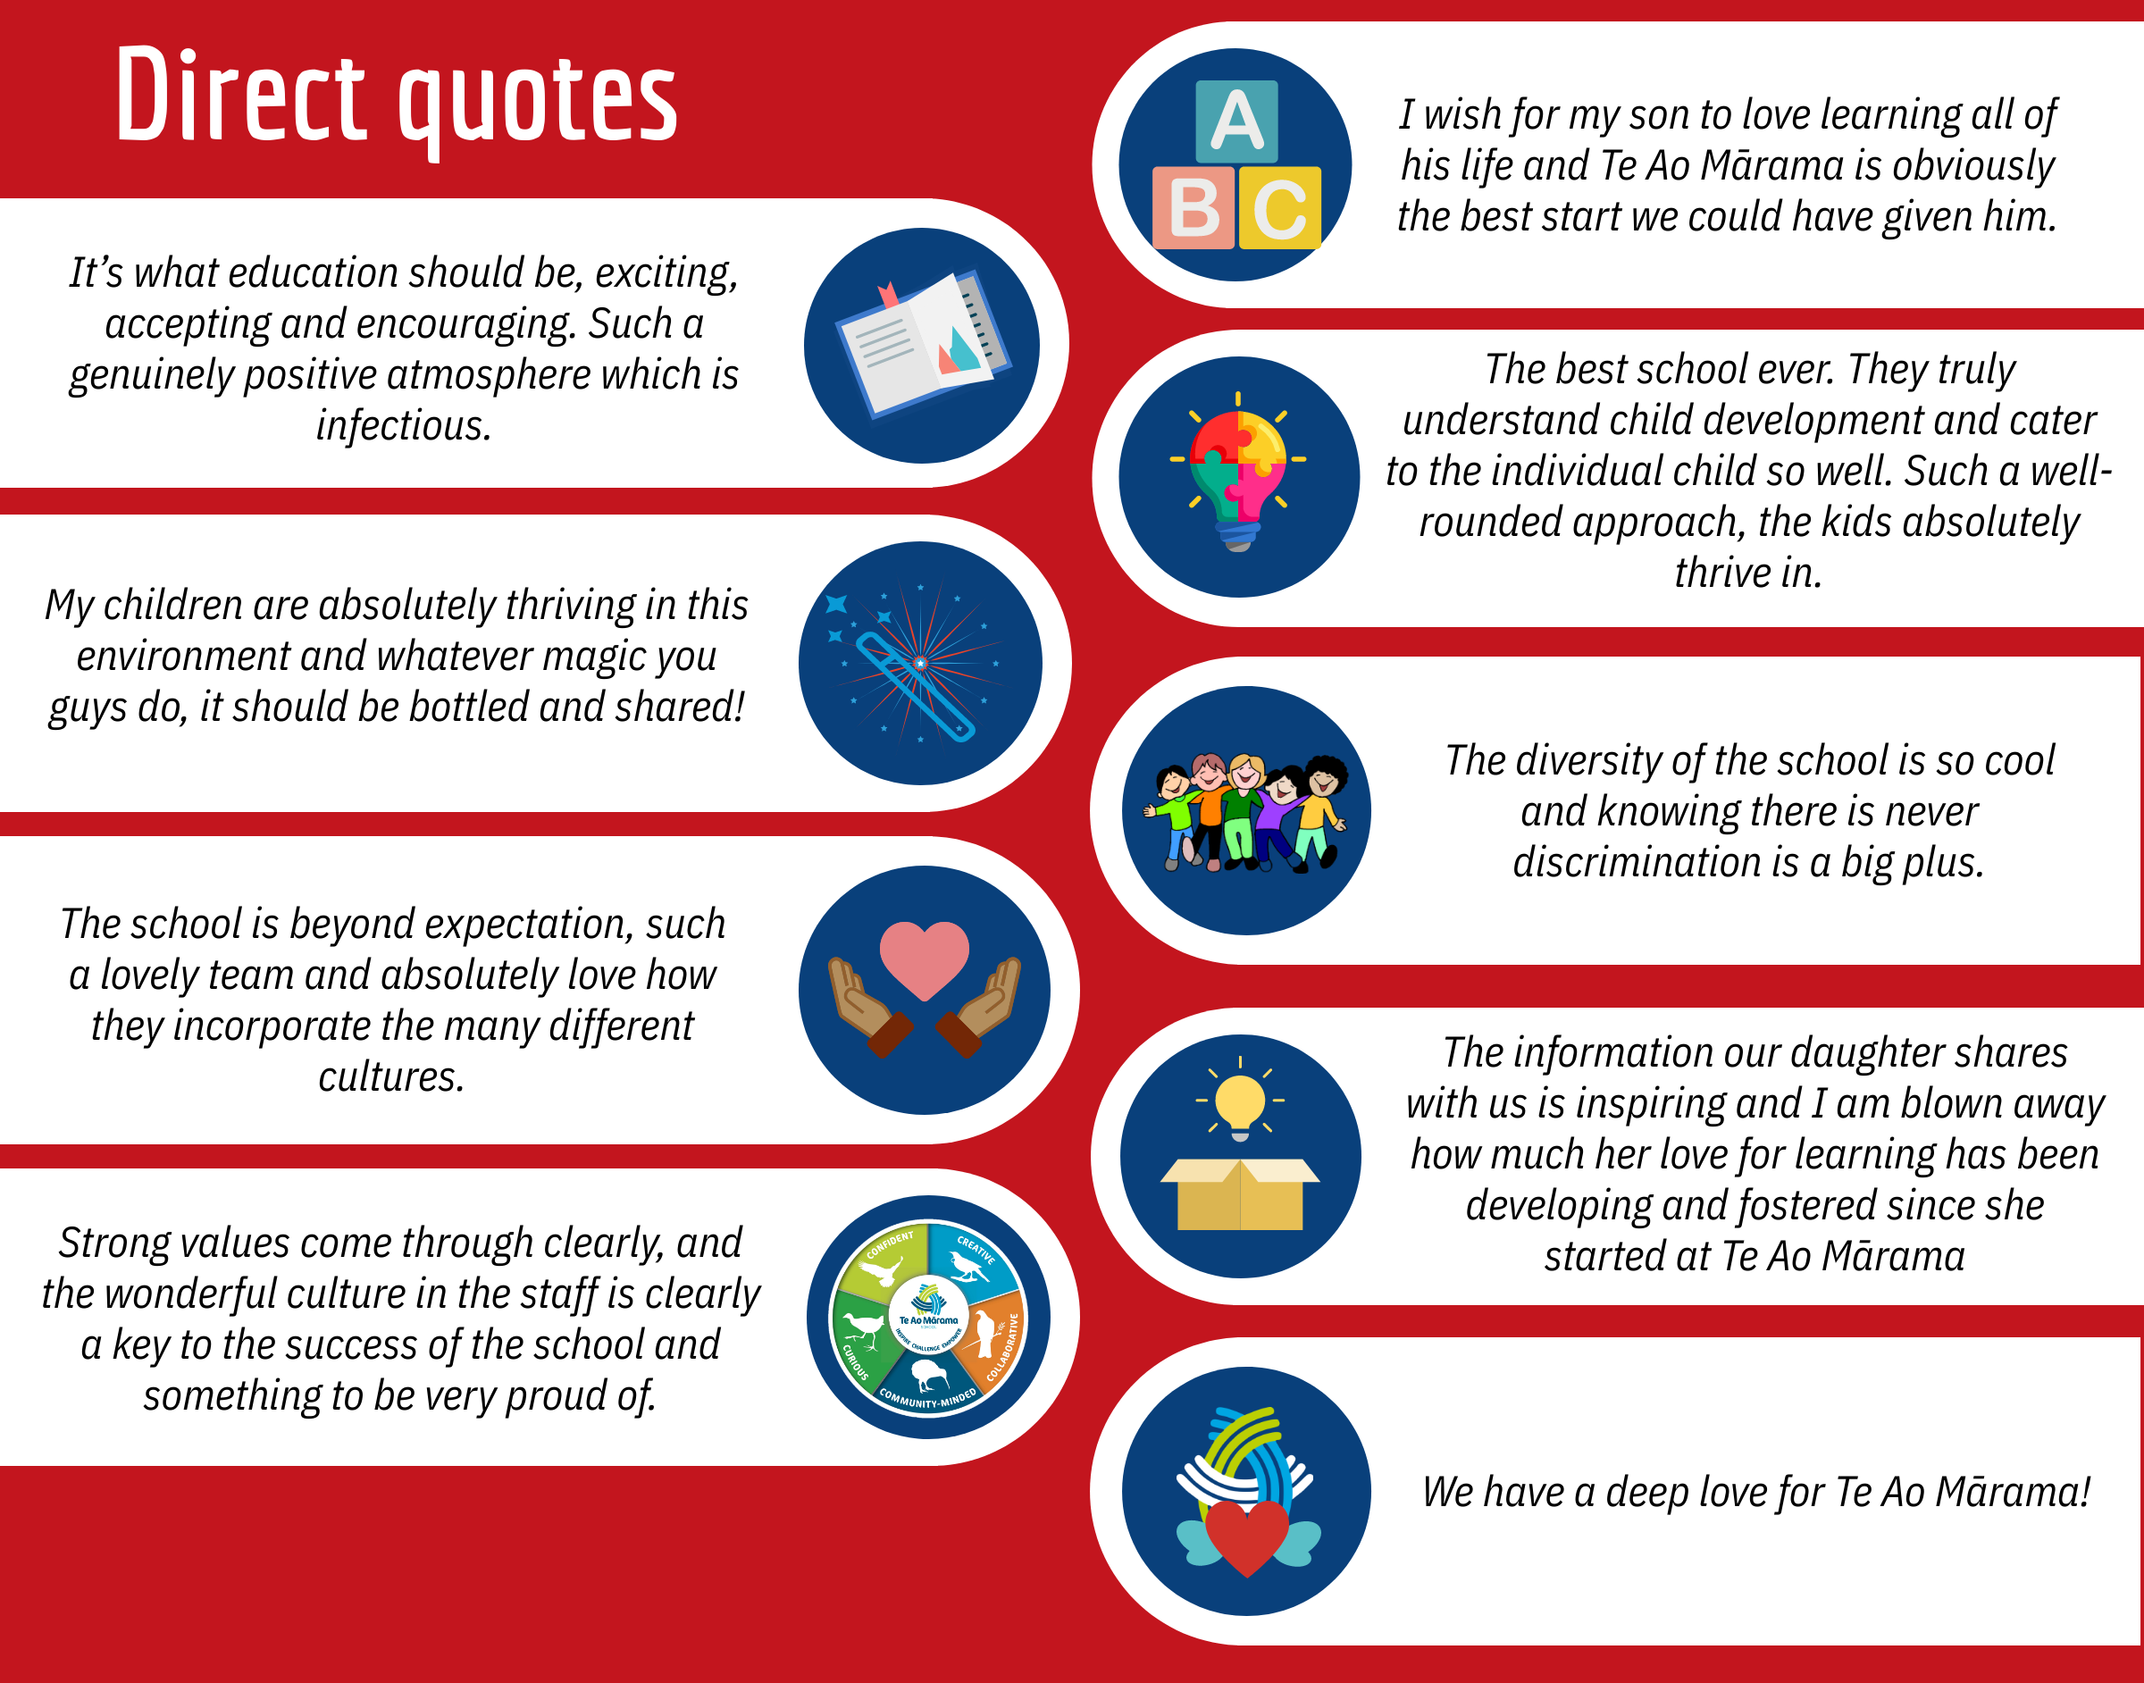

SCHOOL INFORMATION

Much of our information about Te Ao Mārama School is online. We encourage you to view some of the following information. Click on the images below to go to our Facebook and Website.

[](https://www.facebook.com/Te-Ao-Mārama-School-141583596640932/) [](http://www.xn--teaomrama-9bb.school.nz/)



WHAT ROLES DO WE HAVE?

We have two positions available:

1. Permanent Teacher role, starting Term 1, 2026
2. Fixed Term for 2026 (maternity leave) *Note: With our ongoing growth, this could easily turn into fulltime work for 2027+*

You are welcome to apply for both of these roles, and please indicate in your application letter.

Year levels for the roles will be determined when we develop teams based on a strength based approach. There will be a degree of flexibility regarding your preferred year level groups.

**FURTHER INFORMATION AND MEET/GREET

Our Team will be hosting General Information Sessions at the following dates/times.

* + - * Fri 10th October 8.45am*
      * Mon 13th October 3.45pm
      * Wed 15th October 8.45am*

* *these sessions will enable you to see the school in action*

Please complete [this form](https://docs.google.com/forms/d/e/1FAIpQLSfEsICkA2JTP9WWjqKPe82laYNLVI5q5abIR0f_1GidT1LR6w/viewform?usp=sf_link), so we know who is coming and can be prepared for numbers.

During this session we will provide further information, go for a tour of the school, and also provide time for Q & A. You will also have the opportunity to meet some of our current team and to chat to them.

This will give you a sense of *who we are*, and whether you think our school would *be a good “fit” for you.*

We highly encourage candidates to take this opportunity and look forward to hearing from you.

HOW TO APPLY

Please submit the following information by the ***17th October 9am***, via email to [tony@teaomarama.school.nz](mailto:tony@teaomarama.school.nz)

1. Your letter of application
2. Your Curriculum Vitae
3. Your completed application form
4. [Referee responses](https://docs.google.com/forms/d/e/1FAIpQLSd41x1NaLubv4z0HZMVftBmAAgjLS7bSJHY5xmkk4j_wskO2Q/viewform?usp=sf_link) - Please send this google form link to your referees and have them complete the form prior to the ***16th October.***

RECRUITMENT PROCESS TIMELINE

|  |  |
| --- | --- |
| Advertising begins | 7th October |
| Referee Forms due | 16th October |
| Applications close | 17th October 9am |
| Shortlisting and referee checks | By 17th October |
| Interviews | Tues 21st October |
| Positions appointed and advised | Asap after interviews |
| Successful candidates begin | Term 1, 2026 |

APPLICATION CHECKLIST

Thank you again for your interest in our school.

Please take the time to check your application before sending it to us.

***Check that you have:***

1. Completed all sections of the Application Form
2. Completed referee contact details and asked referees to complete the [google form](https://docs.google.com/forms/d/e/1FAIpQLSd41x1NaLubv4z0HZMVftBmAAgjLS7bSJHY5xmkk4j_wskO2Q/viewform?usp=sf_link)
3. Included a Curriculum Vitae
4. Please send an electronic copy to [tony@teaomarama.school.nz](mailto:tony@teaomarama.school.nz)

Please refer to the timeline for details of our deadlines.

This is an incredible opportunity to be part of something special. Not only are we continuing to build a school, but we are also building a team!

We look forward to hearing from you, and hopefully meeting you at one of our upcoming information sessions ☺