
TEACHER VACANCY
2026 APPLICATION PACK


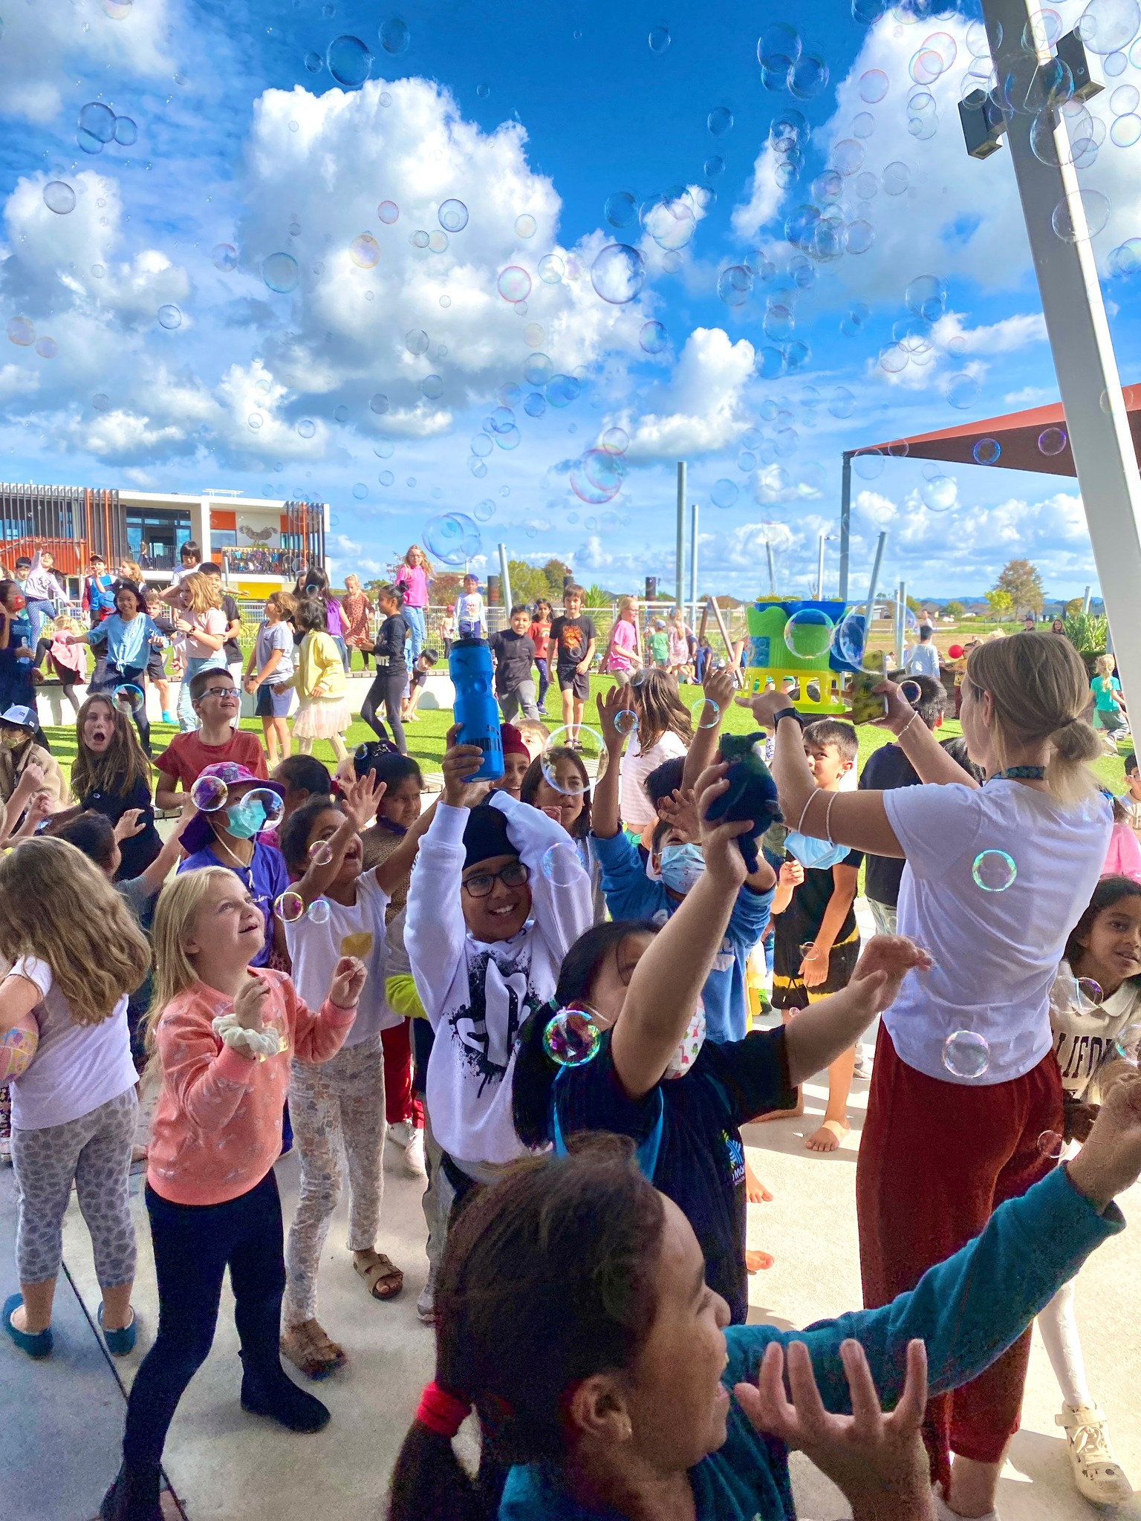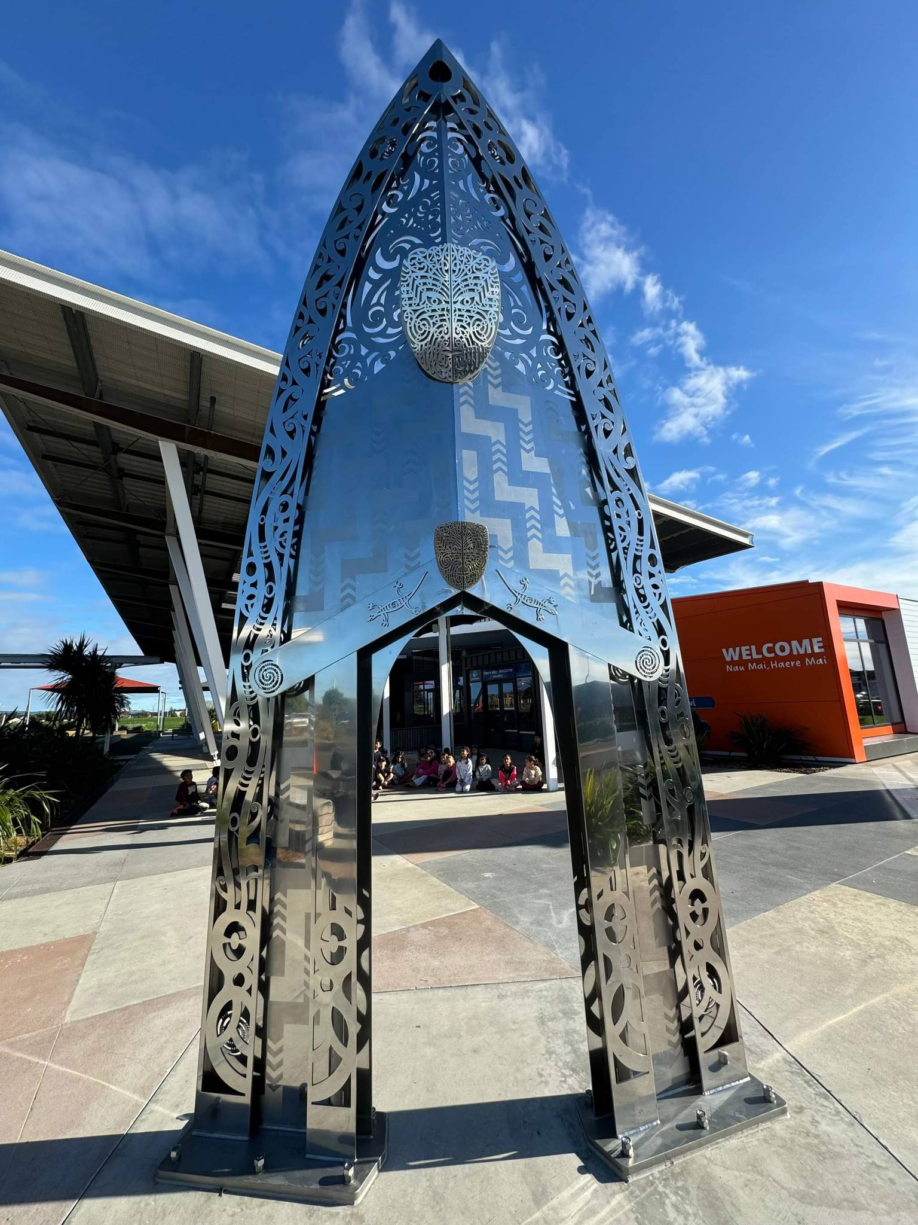

Kia ora,

Thank you for expressing an interest in our recently advertised teaching positions.
Our school opened in 2019 and it has been an exciting journey to establish a new school.
We are looking forward to growing our team!
We believe the culture of our school is one of the special reasons our staff and students thrive.
Our vision is to Inspire, Challenge and Empower, and this is highly evident in our curriculum design and approach to teaching and learning.
The school roll is currently 450 students.
We are a very multicultural community with 56 countries represented, and we enjoy celebrating this diversity. Approximately 50% of our students are learning English as a second language. The school is a Public Private Partnership (PPP) school (buildings owned and maintained by a private company, but every other aspect of the school operates like a public school) designed with innovative learning environments able to accommodate up to 520 students. The school also has a specialist education unit on site which is managed by Hamilton North School.
Please find enclosed all the information you will need to apply. If you win the position you will be part of a pretty special staff culture (please see our culture survey included).
If you are an enthusiastic and innovative teacher with the talent, energy and passion to inspire, then we would love to hear from you.

Ngā mihi nui
Tony Grey
Principal


APPLICATION INFORMATION

The application process and the relevant documents are included in this pack and on our website:
- Application form, including referee details and referee google form
- Application checklist
- Recruitment process/timeline

Applications close at 9am, 3rd March

WHY JOIN OUR TEAM? IN RETURN WE CAN OFFER:
- The incredible opportunity to be part of the team, and to continue to build the school from scratch.
- The opportunity to be part of a strong staff culture, where innovation and fun is fostered. Please refer to our latest Staff Culture survey
- An amazing state of the art learning environment.
- Children of Board employees are eligible for “out of zone” enrolment places, under priority 5 of the enrolment scheme. We also offer free after school care.
- A school that is deeply committed to bringing its vision and values alive.
- Strong support from our Leadership Team and Board, with full commitment to high quality personal and professional development. We invest in our people!
- The opportunity for you to utilise your talents, and to work alongside other passionate and innovative educators.
- The promise that we will inspire, challenge and empower you to become the best possible teacher.
- An incredibly supportive and positive parent community/whānau (see survey responses below)
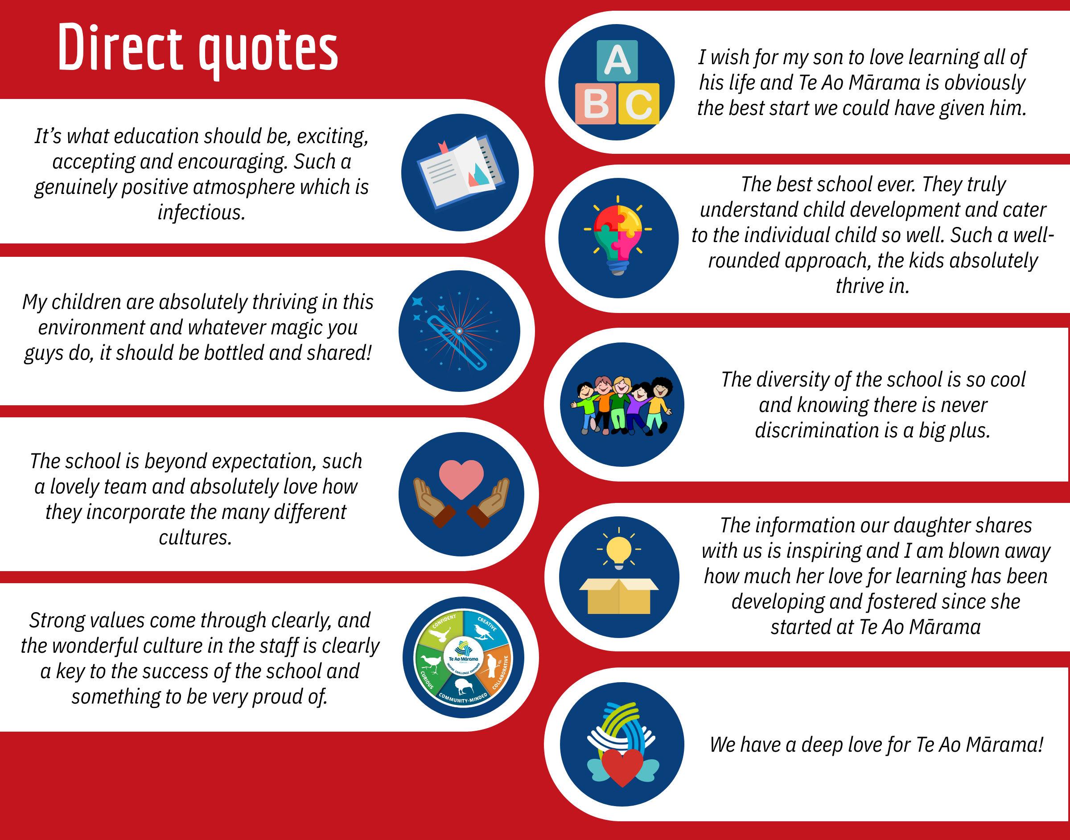

SCHOOL INFORMATION
Much of our information about Te Ao Mārama School is online. We encourage you to view some of the following information. Click on the images below to go to our Facebook and Website.


WHAT ROLES DO WE HAVE?
We have two positions available:
- Fixed Term for 2026, starting Term 2.
- Fixed Term for 2026 (maternity leave), starting Term 2.
Note: With our ongoing growth, we will have permanent roles for 2027+ and will confirm all of these by the end of Term 3, 2026.

Year levels for the roles will be determined when we develop teams based on a strength based approach. There will be a degree of flexibility regarding your preferred year level groups.


FURTHER INFORMATION AND MEET/GREET
Our Team will be hosting General Information Sessions at the following dates/times.
      - Mon 23rd 3.45pm
      - Tues 24th 8.45am*
      - Fri 27th 1.30pm*

* this session will enable you to see the school in action

Please complete this form, so we know who is coming and can be prepared for numbers.
During this session we will provide further information, go for a tour of the school, and also provide time for Q & A. You will also have the opportunity to meet some of our current team and to chat to them.
This will give you a sense of who we are, and whether you think our school would be a good “fit” for you.
We highly encourage candidates to take this opportunity and look forward to hearing from you.

HOW TO APPLY
Please submit the following information by the 3rd March 9am, via email to tony@teaomarama.school.nz

- Your letter of application
- Your Curriculum Vitae
- Your completed application form
- Referee responses - Please send this google form link to your referees and have them complete the form prior to the 2nd March.

RECRUITMENT PROCESS TIMELINE
Advertising begins | 19th February
Referee Forms due | 2nd March
Applications close | 3rd March 9am
Shortlisting and referee checks | 3rd March
Interviews | Friday 6th March
Positions appointed and advised | Asap after interviews
Successful candidates begin | Term 2, 2026 or by negotiation

APPLICATION CHECKLIST
Thank you again for your interest in our school.
Please take the time to check your application before sending it to us.

Check that you have:
- Completed all sections of the Application Form
- Completed referee contact details and asked referees to complete the google form
- Included a Curriculum Vitae
- Please send an electronic copy to tony@teaomarama.school.nz

Please refer to the timeline for details of our deadlines.
This is an incredible opportunity to be part of something special. Not only are we continuing to build a school, but we are also building a team!
We look forward to hearing from you, and hopefully meeting you at one of our upcoming information sessions

